**AWS: Send custom email notification for CD pipeline**

Step 1: Set up an email notification using Amazon SNS

* Open SNS Console and Create a SNS topic

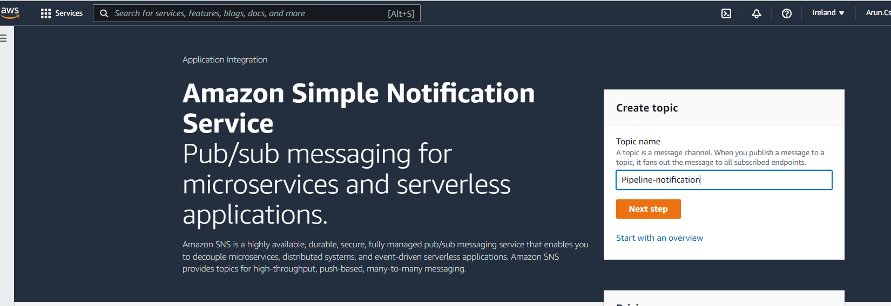

* Open the SNS topic and configure the below steps
* In the Amazon SNS console, from the **Topics** list, select the check box next to your new topic. Choose Actions, Subscribe to topic.
* In the Create subscription dialog box, verify that an ARN appears in Topic ARN.
* For Protocol, choose Email.
* For Endpoint, type the recipient's full email address.
* Choose Create Subscription.
* Amazon SNS sends a subscription confirmation email to the recipient. To receive email notifications, the recipient must choose the Confirm subscription link in this email.

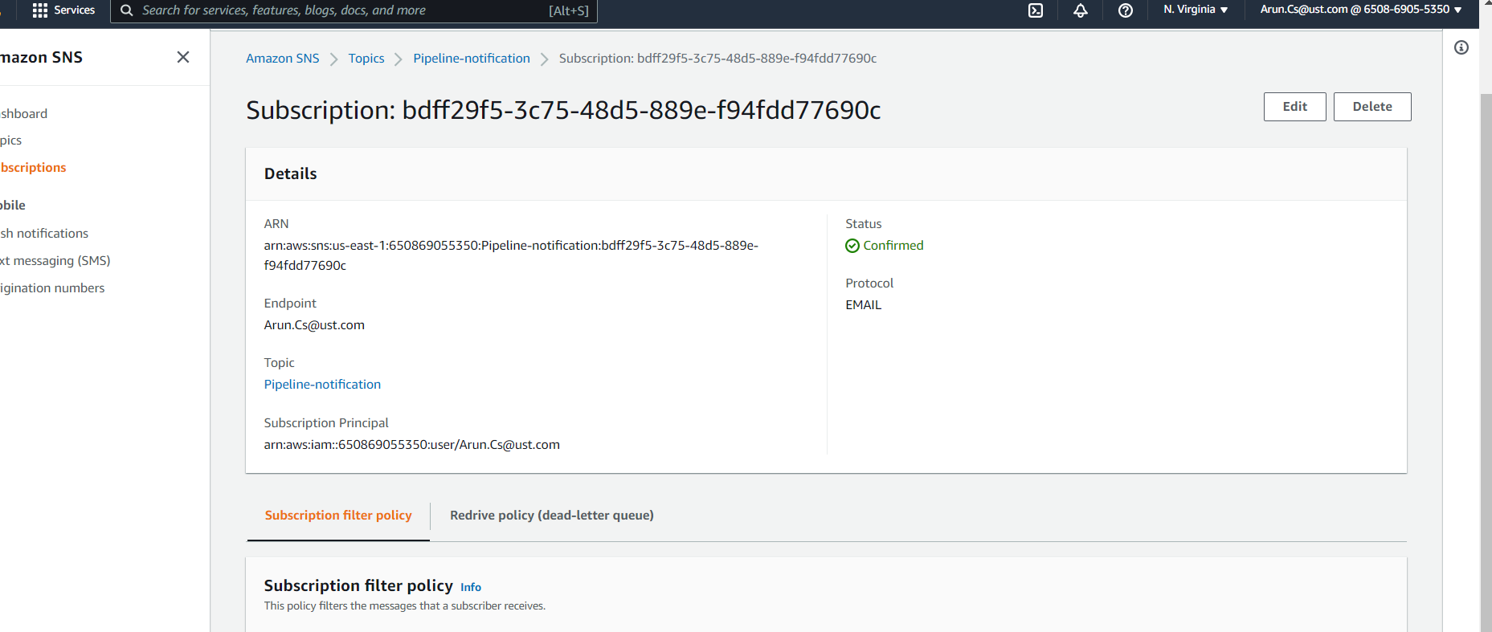

Step 2: Create a CloudWatch Event notification rule and add SNS topic as Target

* Open the CloudWatch console and In the navigation pane, choose Events.
* Choose Create rule. Under Event source, choose AWS Code Pipeline. For Event Type, choose Pipeline Execution State Change.

**For Individual Pipeline**

* Choose Specific state(s), and choose **f**ailed

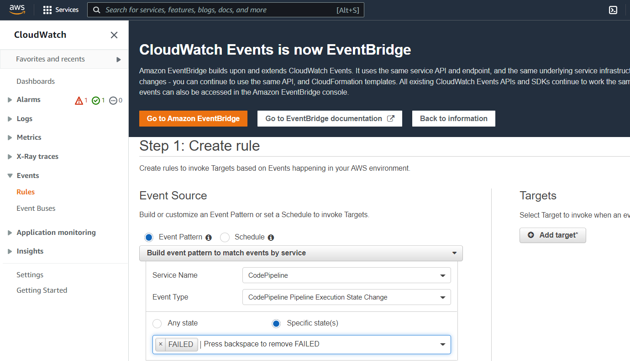

* Choose Edit to open the JSON editor for the Event Pattern Preview pane. Add the pipeline parameter with the name of your pipeline

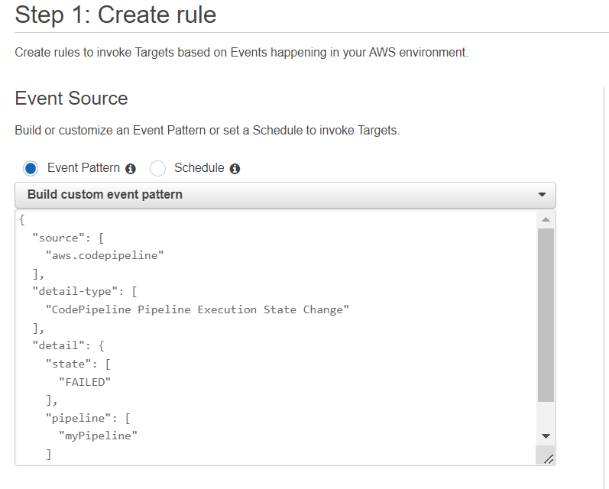

* For Targets, choose Add target, In the list of targets, choose SNS topic. For Topic, enter the topic you created.
* Expand Configure input, and then choose Input Transformer, In the Input Path box, type the following key-value pairs.

**{ "pipeline" : "$.detail.pipeline" }**

* In the Input Template box, type the message

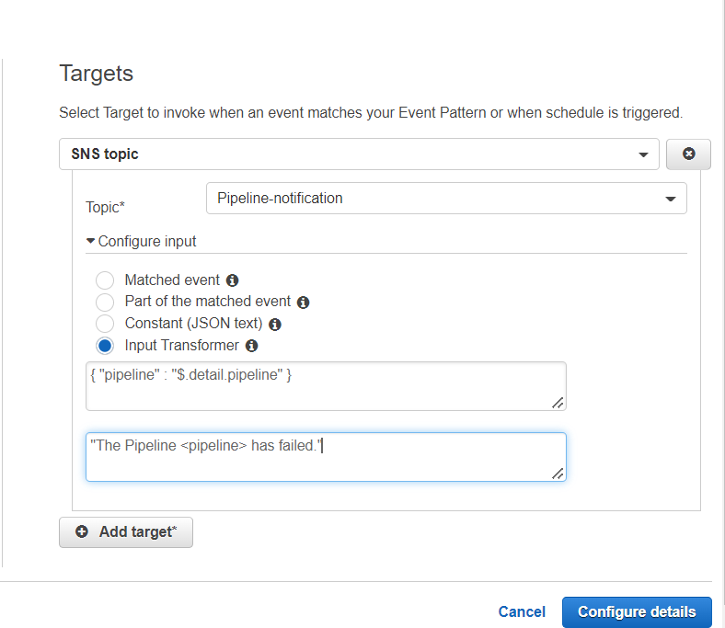

**For All Pipeline**

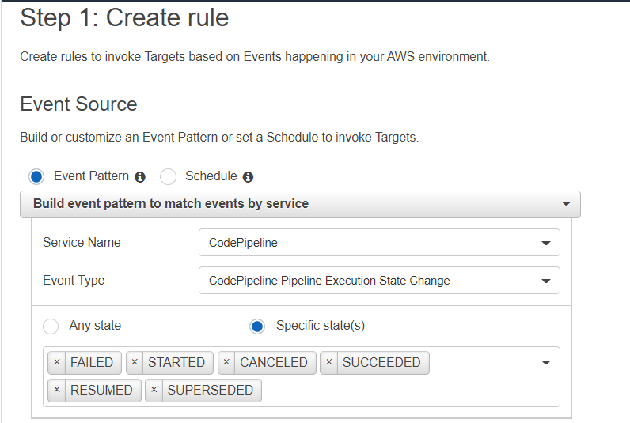

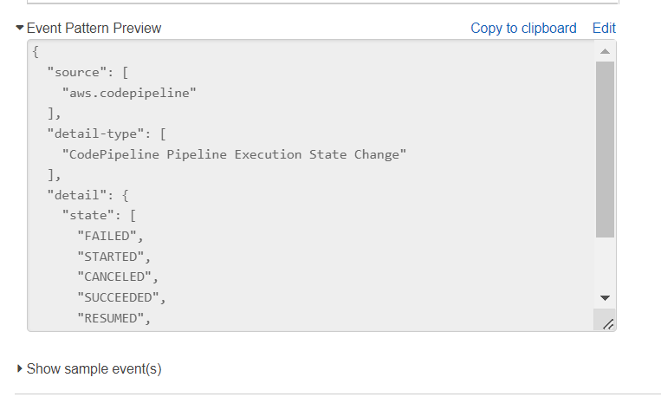

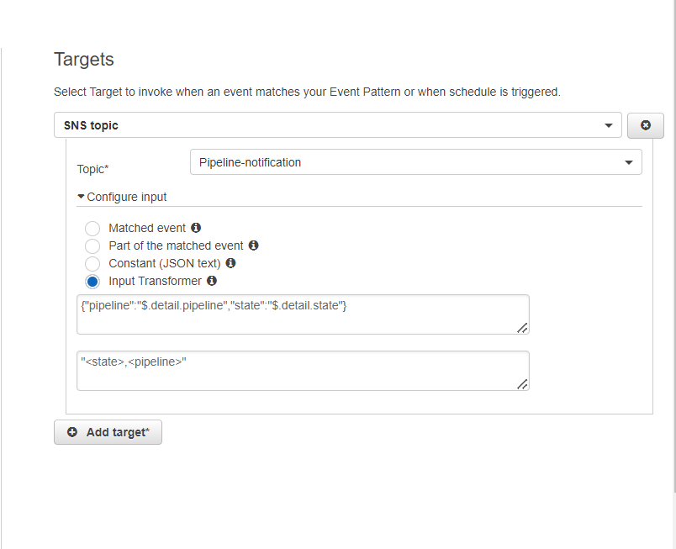

* Choose Configure details, On the Configure rule details page, type a name and an optional description. For State, leave the Enabled box selected and Create rule.

